**Assignment 4: Assignment on Filtering**

Implement a gaussian filter following the below instructions:

1. You are free to take any image you want. But try to take a clear and well resolution image, in which the output will be clearly visible.

1. User will give the value of sigma as input. Note that, the sigma value i.e., the value of the standard deviation can be any numeric value. The higher the value, the more the image will be blurred.

The following image demonstrates the input:

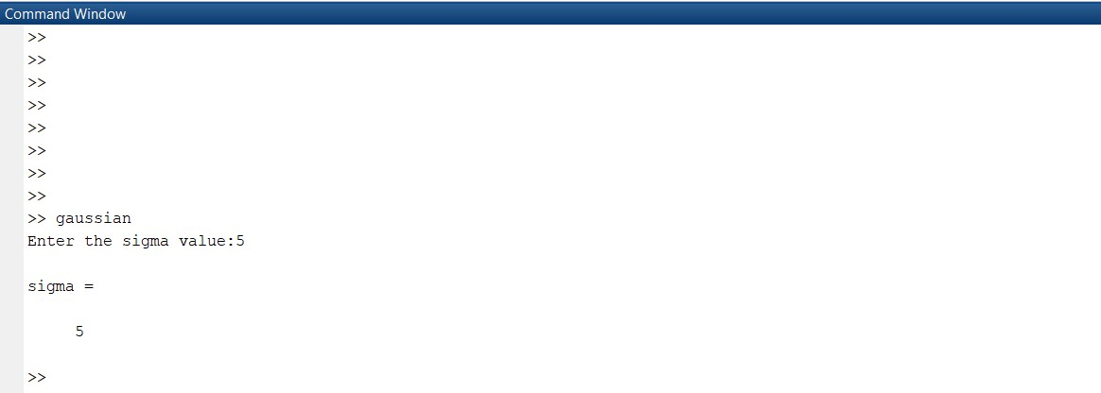

1. You should design the gaussian kernel like this:

Divide your roll number by 4. And take the remainder. Then use the following chart-

|  |  |
| --- | --- |
| **Remainder** | **Kernel Size** |
| If (ID % 4) == 0 | 3X3 |
| 1 | 5X5 |
| 2 | 7X7 |
| 3 | 11X11 |

For example, for Id 12, if we divide 12 by 4, we get the remainder of 0. So, Id 12 will design a 3X3 gaussian kernel for filtering.

1. In our provided code, there is a little bug which you have to fix it in this assignment. The bug is: the kernel is not center-based; that is - after computing the linear operation, the output is placed at upper left corner (see figure-a). But the correct way to do this is shown

in figure (b) where the output is placed in the center of the kernel. In your assignment, you must follow the correct approach. Moreover, the boundary issues must be handled properly in your code.

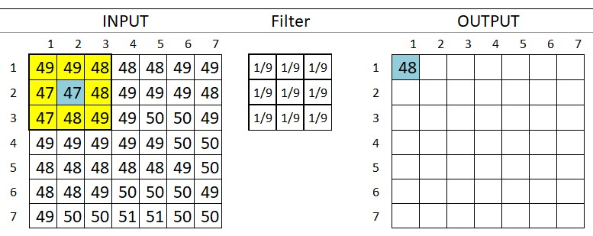

* 1. Incorrect approach

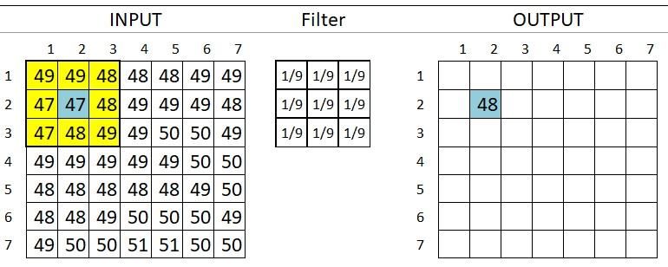

* 1. Correct approach

1. **Most importantly, you cannot use any inbuilt function for filtering here.**

1. Please submit the .m file, the input image and the output image in a folder. Rename the folder with your id, zip it and then submit it.

1. The following images demonstrate the input image and the output image.

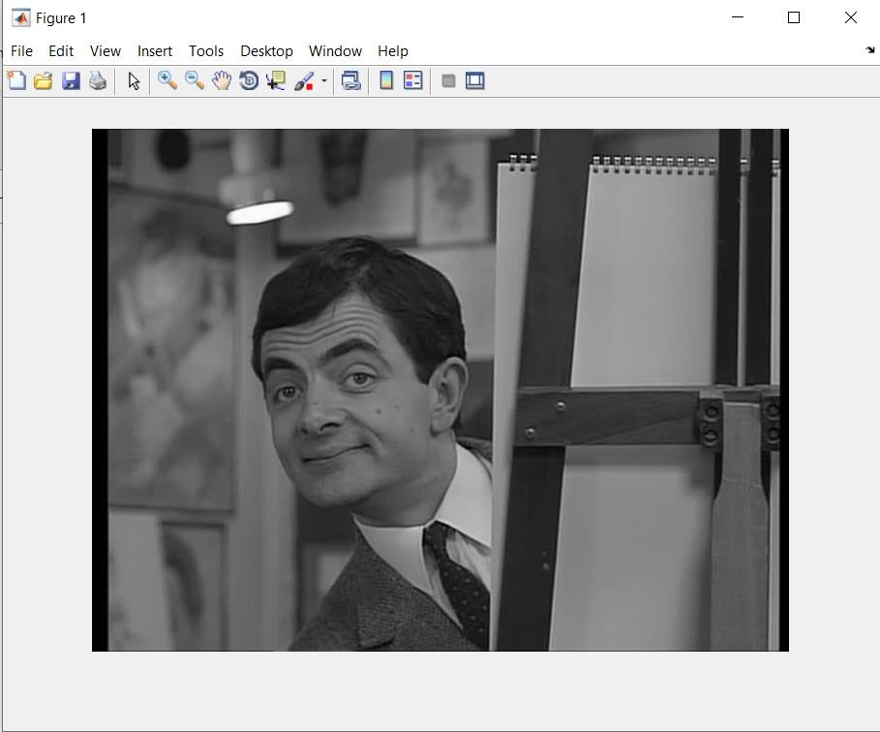

* 1. Input Image

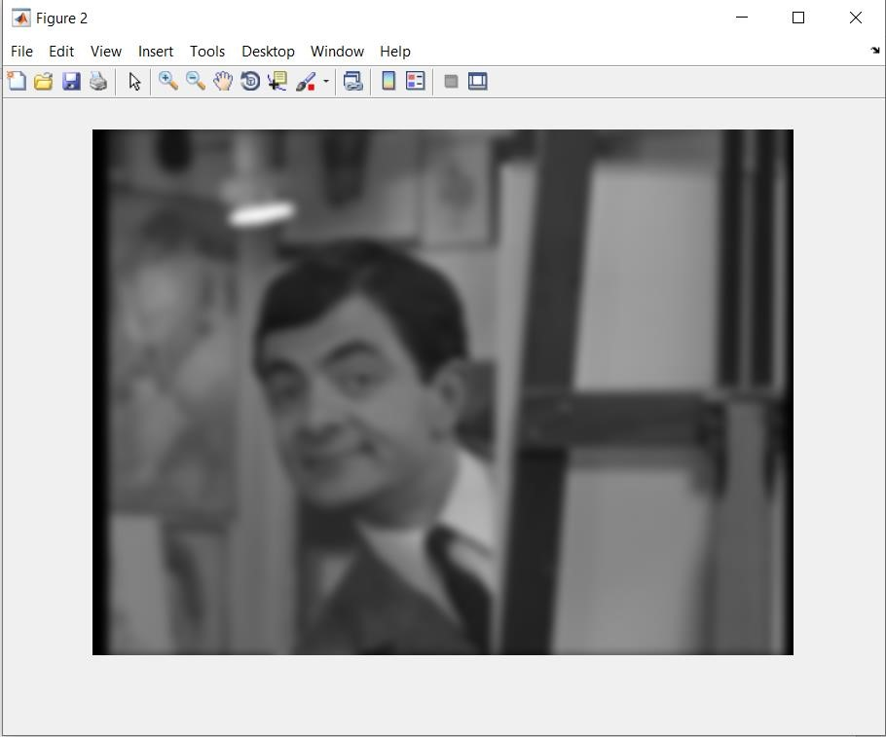

* 1. Output Image (with a sigma value of 5)